Template – Execute Query to Populate a Grid
The template named “Template – Execute Query Populate Grid Example” is applicable to Anthology Student.

Purpose and Outcome
This template provides a form sequence and supporting workflow that uses an ExecuteQuery activity to retrieve a data set and then loop through each data row to populate a grid. Based on the term selected by the user, the query is executed and billing information is displayed in a grid.
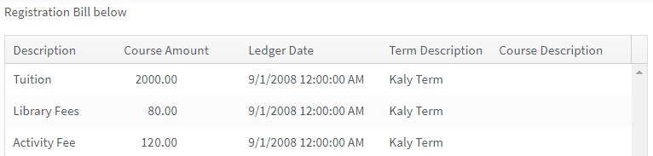
The sequence requires the following:
- A complete Student record must exist in the Anthology Student database.
- The student must have a Portal login to log into this authenticated sequence.

Prerequisites
The template was built with Forms Builder using the applications listed below. The template is forward compatible with later versions of the listed applications.
Application | Compatibility Version
Forms Builder Designer and Renderer | Compatibility Matrix
Web Client for Anthology Student
Workflow Composer
Packages installed from Package Manager in Workflow Composer | Activities and Contracts (V2)  Contracts (V1)  Forms Builder Contracts  Note: Ensure that the Forms Builder Contracts package used in Workflow Composer is aligned with the version used in the Forms Builder. Additionally, confirm that both Activities and Contracts (V1) and Activities and Contracts (V2) packages in Workflow Composer match the versions used in the Student Web Client to avoid compatibility issues.  It depends on which product is being used, for example:  For CRM:  Activities And Contracts (CRM)  Forms Builder Contracts
Workflow Tracking Database | N/A
Staff STS | 3.3.x

Step 1: Download and Import the Template
- Download the template file to your environment (local drive or network location).
- Log into Forms Builder and select the Form Designer tile.
- Click the Export/Import tile.
- Select the Import tab.
- Click Select exported file and navigate to the downloaded template file.
- Click Import.
Note: Import may fail if same files name is already available in environment or overwrite option.

- Export/Import

The following forms will be imported:
- RegBillv3-1
- RegBillv3-2
- RegBillv3-3
- GeneralEndStateForm

Step 2: In Form Designer…
- From the Forms slide out, select the RegBillv3-1 form.
- Customize the form for your environment. Modify properties on fields/components to make them required, etc., or add/remove fields on form.
- Fields and Components
- Save the form.
- Repeat steps 1-3 for the remaining forms as appropriate for your institution.
Notes:
- Do not change the properties of the Grid component in the RegBill3-3 form. The Property Names in the grid correlate with assign statements and queries in the workflow. The results of the ExecuteQuery activity are bound to the grid.
- Do not enable the Add, Edit, or Delete options in the grid. The grid is meant to be read- only.
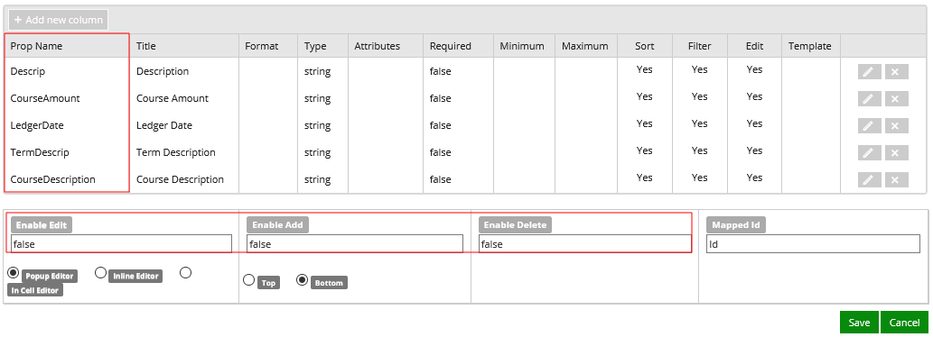

Step 3: In Sequence Designer…
- Locate the RegBillv3 sequence in the Sequences pane.
- Click Save As to create a copy of the sequence/workflow and customize the copy for your use. This way you can always refer to the original sequence/workflow you downloaded.
- Optional - Customize the sequence properties for your environment.
- Optional - Add a custom style (theme) for your campus.
- Themes
- Select your saved sequence in the Sequences pane.
- In the Properties Pane, as End State Form, select the imported “GeneralEndStateForm”.
- Save the sequence.

Step 4: In Workflow Composer…
- Open the workflow for your saved sequence.
- Opening Workflows for Sequences
- Explore the arguments, variables, states, and transitions to get an understanding of the workflow logic. This is a state machine workflow. Each form is a state. The arrows are transitions from one state to another.
- State Machine Workflows
- You do not need to modify anything is the workflow if you did not modify the Grid component.
Note that the ExecuteQuery activity on the RegBill3-3 state uses a complex query which retrieves charges that are posted or pending for the student for the selected term:
"select SaBillCode.Descrip+' '+'(Pending)' as Descrip, SaPendingCharge.Amount, SaPendingCharge.Type, SaPendingCharge.DateAdded as Date, (select AdTerm.Descrip from AdTerm(nolock) where AdTerm.AdTermID= SaPendingCharge.AdTermID ) as TermDescrip, 0 AS CourseAmount, '' AS CourseDescription from dbo.SaPendingCharge SaPendingCharge Inner Join dbo.SaBillCode SaBillCode (nolock) on SaPendingCharge.SaBillCodeID=SaBillCode.SaBillCodeId inner join AdTerm (nolock) on AdTerm.AdTermID = case when SaPendingCharge.RegAdTermID IS not null then SaPendingCharge.RegAdTermID else SaPendingCharge.AdTermID end where SaPendingCharge.SyStudentID =" + SyStudentId.ToString + "and SaPendingCharge.AdTermId =" + Test.ToString + "Union All Select SaTrans.Descrip, SaTrans.Amount, SaTrans.Type, SaTrans.[Date] as Date, AdTerm.Descrip as TermDescrip, IsNull (SaTransCourseAmount.Amount, 0) AS CourseAmount, AdCourse.Descrip AS CourseDescription From dbo.SaTrans (nolock) inner join AdTerm (nolock) on AdTerm.AdTermID = SaTrans.AdTermID left join saTransCourseAmount on saTrans.saTransID = saTransCourseAmount.saTransID left join AdCourse on AdCourse.AdCourseID = SaTransCourseAmount.AdCourseID where SaTrans.SyStudentID =" + SyStudentId.ToString + "and SaTrans.AdTermId =" + Test.ToString

Step 5: In Forms Renderer…
Select your sequence and try it out!
- Sequence List
- Find your sequence and copy the URL to the clipboard.
- Paste the URL into a browser and complete the form sequence.
- Login to Portal as a student and verify that the grid displays the appropriate data for a selected term.

Step 6: Lastly…
Once your updated sequence has been tested successfully, it is recommended that you disable the workflow for the original Template version.
- In Workflow Composer, in the Server section of the ribbon, click Open.
- Find the workflow named RegBillv3.
- Clear the Enabled check box and click Save.

